Project Design Phase-II
Data Flow Diagram & User Stories

Date | 30 October 2026
Team ID | NA
Project Name | Electric Vehicle Market Performance & Insights
Maximum Marks | 4 Marks

Data Flow Diagrams:
A Data Flow Diagram (DFD) is a traditional visual representation of the information flows within a system. A neat and clear DFD can depict the right amount of the system requirement graphically. It shows how data enters and leaves the system, what changes the information, and where data is stored.
DFD Symbol Legend
Symbol | Name | Description
Oval / Rounded  shape | External Entity | A person, organization, or system outside the project that sends or receives data (e.g., Customer, Payment Gateway).
Rectangle with  numbered header | Process | An activity that transforms incoming data into outgoing data (e.g., Validate Request, Process Order).
Rectangle (solid fill, no number) | Data Store | A place where data is held for later use (e.g., Customer Database, Inventory).
Labeled arrow | Data Flow | The movement of data between entities, processes, and data stores, labeled with what data is being passed.

Data Flow Diagram (Level 1):
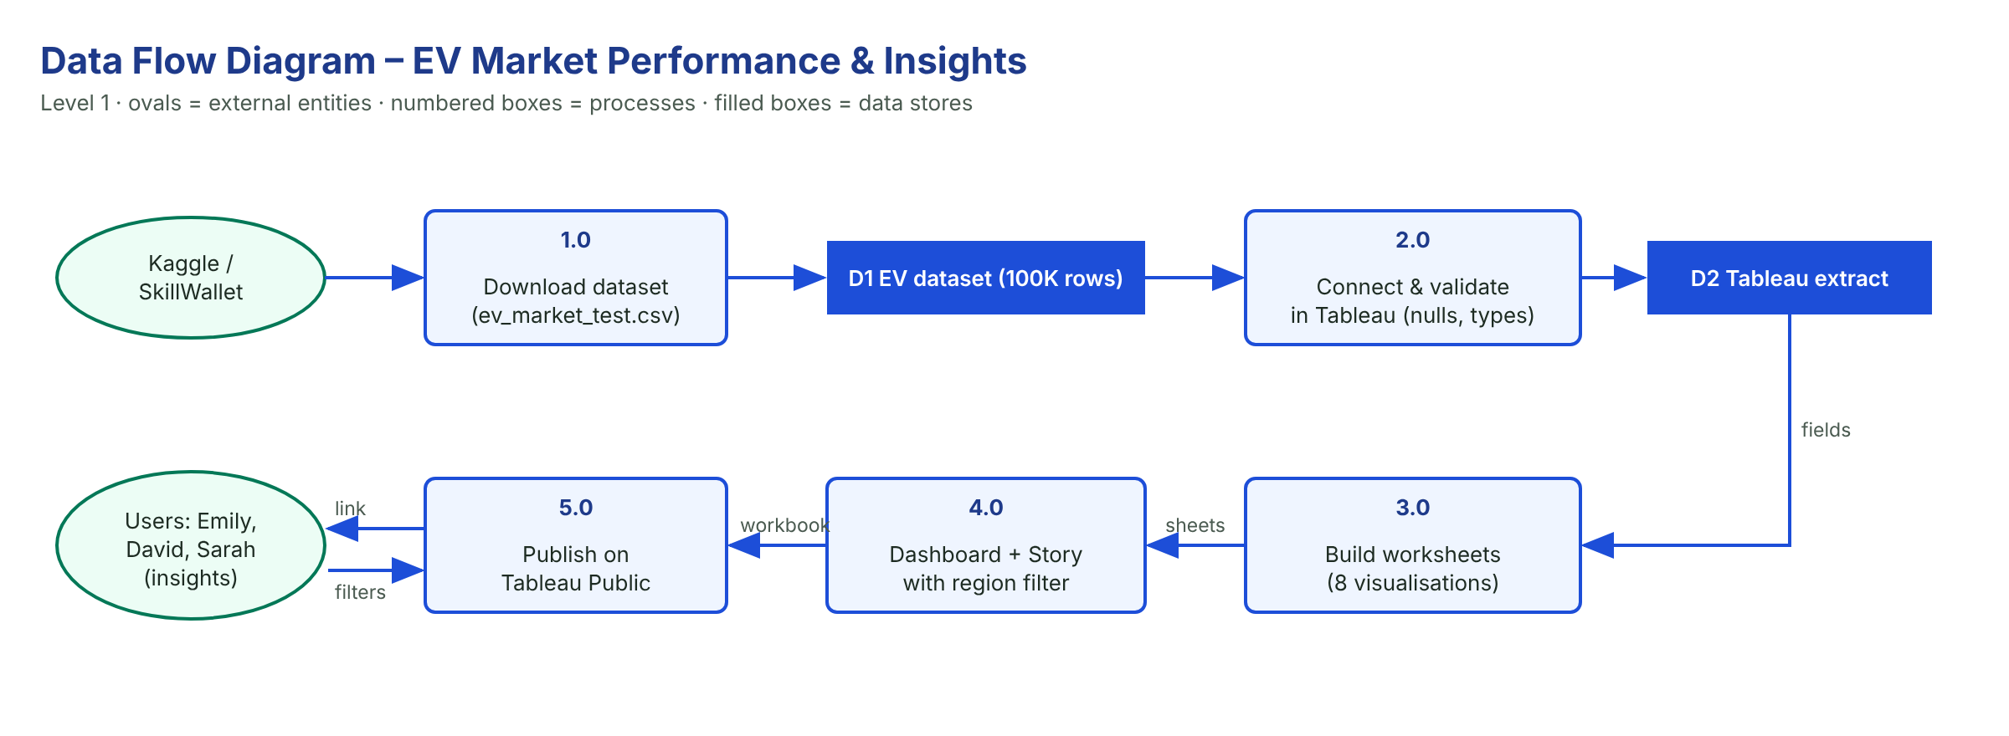

User Stories
Use the below template to list all the user stories for the product.
User Type | Functional Requirement (Epic) | User Story Number | User Story / Task | Acceptance criteria | Priority | Release
Strategy Director (Emily) | Category Sales | USN-1 | As a strategy director, I can see annual EV sales for every vehicle category. | Sorted bar chart of 15 categories | High | Sprint-2
 | Range | USN-2 | As a strategy director, I can compare average driving range by category. | Bar chart sorted by average range | Medium | Sprint-2
 | Trend | USN-3 | As a strategy director, I can view sales by model year. | Line chart 2018–2026 | Medium | Sprint-3
BI Manager (David) | Regions | USN-4 | As a BI manager, I can compare sales across market regions. | Bar chart of 7 regions | High | Sprint-2
 | Manufacturers | USN-5 | As a BI manager, I can see the top 10 manufacturers by sales. | Top-10 bar chart | High | Sprint-2
 | Ratings | USN-6 | As a BI manager, I can see the top 10 manufacturers by customer rating. | Top-10 rating chart | Medium | Sprint-3
 | Filter | USN-7 | As a BI manager, I can filter the dashboard by market region. | Charts update on filter change | High | Sprint-3
Researcher (Sarah) | Battery Mix | USN-8 | As a researcher, I can see how many vehicles use each battery type. | Bar chart of 5 battery types | High | Sprint-2
 | CO₂ Savings | USN-9 | As a researcher, I can compare yearly CO₂ savings by category. | Bar chart of average CO₂ saved | High | Sprint-2
 | Story | USN-10 | As a researcher, I can follow a Tableau Story of the main findings. | Story published online | Medium | Sprint-3
Analyst (Developer) | Data Check | USN-11 | As an analyst, I can verify data types, nulls and duplicates before building charts. | 0 duplicates; nulls documented | High | Sprint-1
 | Publishing | USN-12 | As an analyst, I can publish the dashboard to Tableau Public. | Public link works | High | Sprint-4

